NANONETS AGENTS
Step-by-Step Guide
Automated Invoice Processing → Google Sheets

What you will build:
An AI agent that automatically reads invoice PDFs and extracts Invoice Number, Date, Vendor Name, and Total Amount — then saves everything to a Google Sheet. No manual data entry.
Scalability of Nanonets Agents
- Process 10 or 10,000 invoices — same setup, zero extra effort
- Parallel processing: multiple batches run simultaneously in the cloud
- Any team member can trigger it just by forwarding an email — no login or training needed
- Chain multiple agents (extract → approve → log to ERP) for full Accounts Payable automation
- Scales across systems: Google Sheets today, SAP / Dynamics / PostgreSQL tomorrow

Nanonets Agents vs ChatGPT

- Runs automatically: Nanonets triggers on incoming email. ChatGPT requires a human to manually prompt it every single time.
- Saves data directly: Nanonets writes to Google Sheets, SAP, Dynamics, and more via native connectors. ChatGPT has no write access to any external system — you copy-paste the output yourself.
- Batch processing: Nanonets handles 10+ invoice files in one go, concurrently. ChatGPT processes one file at a time and requires re-prompting for each.
- Audit trail: Nanonets logs every task with a Task ID, status, timestamps, and extracted fields — useful for compliance. ChatGPT has no audit or tracking capability.
- ERP integrations: Nanonets connects natively to SAP, Microsoft Dynamics, Sage Intacct, PostgreSQL, and more. ChatGPT offers none of these.
- Accuracy on financial data: Nanonets is purpose-built for structured document extraction with defined fields. ChatGPT can hallucinate values on financial figures with no validation layer.
Bottom line:
ChatGPT is a conversation tool — you ask, it answers, you do the rest manually. Nanonets Agents is a business automation platform — it runs on a trigger, extracts data, saves it to your systems, and logs everything. For any process that needs to run repeatedly, produce structured output, and require no human in the loop, Nanonets is the better choice.
Prerequisites
Before you begin, make sure you have the following ready:

- Free account: A Nanonets account
- Sign up at nanonets.com — free tier is sufficient for this guide
- Google account: A Google account
- Required to connect Google Sheets as the output destination
- Invoice PDF files: Sample invoice PDFs
- You will need at least a few invoice PDFs to test. Nanonets also provides sample files.

💡 No coding required. This entire workflow is built through Nanonets' visual interface.

Overview of the Workflow
Here is what the automated pipeline looks like from end to end:

- Upload invoice PDFs to the Nanonets agent via email
- The AI agent reads each invoice and extracts key fields
- Extracted data is automatically written to a Google Sheet
- You can review results, track status, and run follow-up queries

💡 Nanonets agents work across ERPs, email inboxes, and approval chains — completing processes your team would otherwise do manually.

Step 1: Sign Up and Access Nanonets Agents

Step 1A | Go to the Nanonets website  Open your browser and navigate to nanonets.com. Click 'Get Started' or 'Book a Demo'. For this guide, use 'Get Started' to create a free account.

Figure 2: Nanonets homepage — click 'Get Started' to create your free account

Step 1B | Log in to Nanonets Agents  After signing up, navigate to agents.nanonets.com. You will land on the Nanonets Agents dashboard — the central hub where all your agent tasks and configurations live.

📸 Screenshot: Nanonets 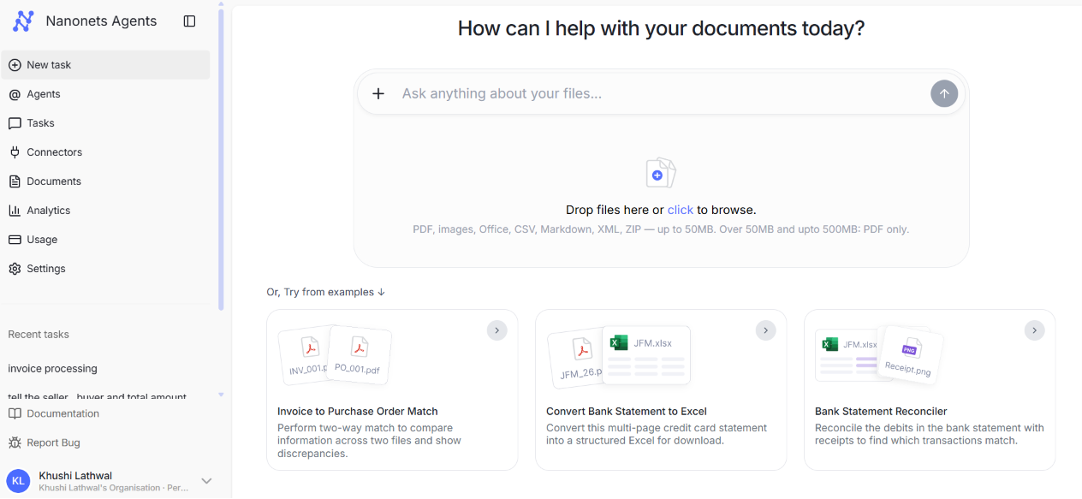Agents dashboard — 'How can I help with your documents today?'

💡 Your dashboard shows recent tasks on the left sidebar. The main area allows you to upload files or try example workflows like Invoice to PO Match, Bank Statement to Excel, and Bank Statement Reconciler.

Step 2: Connect Google Sheets (API Connector)
Before building the agent, you need to connect your Google account so the agent can write data to Google Sheets.

Step 2A | Open the Connectors page  In the left sidebar, click 'Connectors'. This page lists all available API integrations including Microsoft Outlook, SharePoint, Gmail, Teams, Google Sheets, and more.

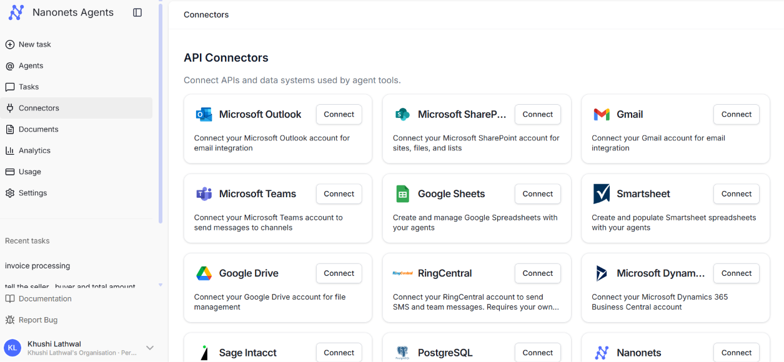📸 Screenshot: Connectors page showing API Connectors grid (Outlook, SharePoint, Gmail, Teams, Google Sheets, etc.)

Step 2B | Connect Google Sheets  Find the Google Sheets tile. If the button says 'View', it is already connected. If it says 'Connect', click it and follow the OAuth flow to authorize your Google account.

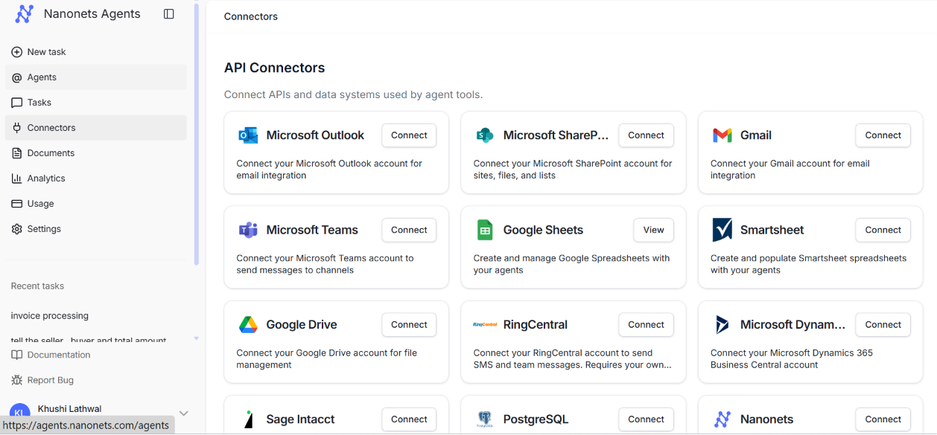📸 Screenshot: Connectors page — Google Sheets tile showing 'View' (already connected) vs. 'Connect'

💡 You only need to connect Google Sheets once. After authorization, Nanonets securely stores the OAuth token and uses it for all future agent tasks under your account.

Step 3: Create a New Agent
Now you will build the agent that will process invoices automatically.

Step 3A | Click 'Agents' in the sidebar  In the left sidebar, click 'Agents', then click '+ New Agent' or 'New task' to start creating your agent.

Step 3B | Write the agent instruction  In the 'Configure' tab, under 'Role and Behaviour', type the following instruction in the text box on the right:

When a new invoice is uploaded, extract invoice number, date, vendor name, and total amount and save it to Google Sheets

📸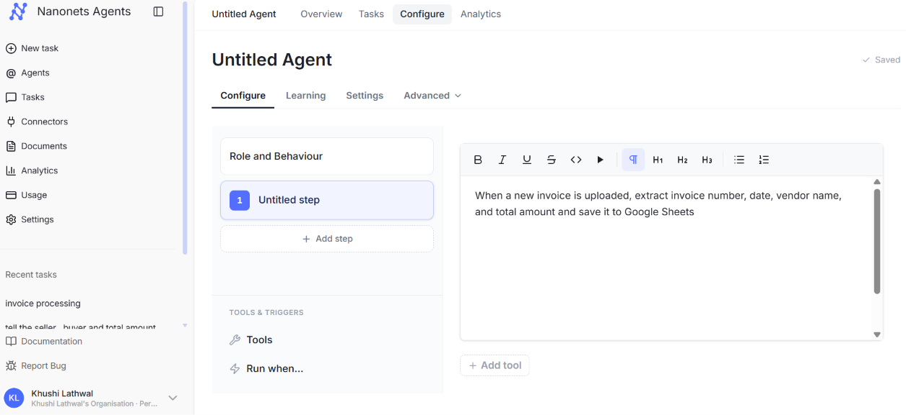 Screenshot: Agent Configure tab — instruction text entered in the behaviour box

💡 This plain-English instruction is all the agent needs. Nanonets' AI understands what to extract and which tool to use — you do not need to write any code or configure field mappings manually.

Step 4: Add the Google Sheets Tool
Now link the Google Sheets connector so the agent knows where to save the extracted data.

Step 4A | Click '+ Add tool' at the bottom  Below the instruction box, click '+ Add tool'. A search box will appear.

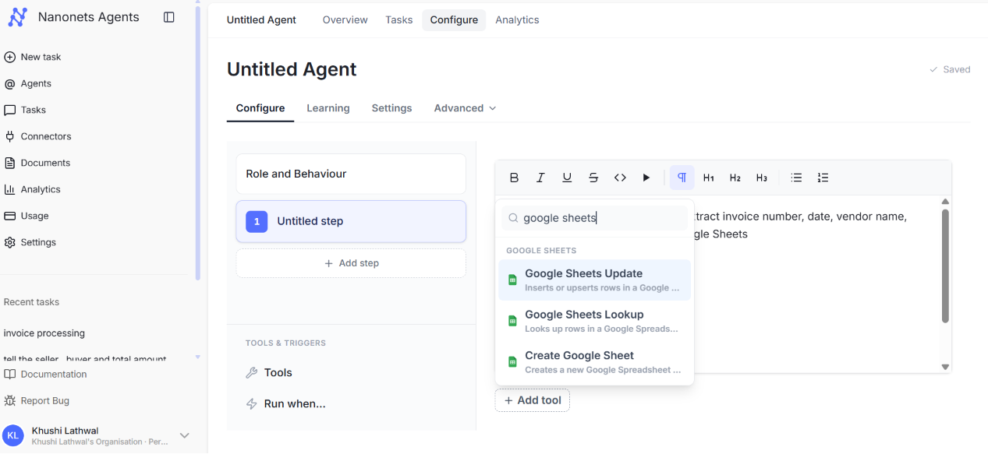📸 Screenshot: Agent Configure tab — '+ Add tool' button at the bottom of the instruction panel

Step 4B | Search for 'Google Sheets'  Type 'google sheets' in the search box. You will see three options appear: Google Sheets Update, Google Sheets Lookup, and Create Google Sheet. Select 'Google Sheets Update'.

📸 Screenshot: Tool search dropdown showing Google Sheets Update, Google Sheets Lookup, Create Google Sheet

Step 4C | Configure the tool  A 'Create Configured Tool' dialog will open. Fill in:

- Display Name: Display Name:
- e.g., "saves extracted invoice data to google sheets"
- Description: Description:
- Optional — helps the AI understand when to use this tool
- Access Token: Access Token:
- Click the dropdown and select your connected Google account (e.g., google_sheets yourname@gmail.com)

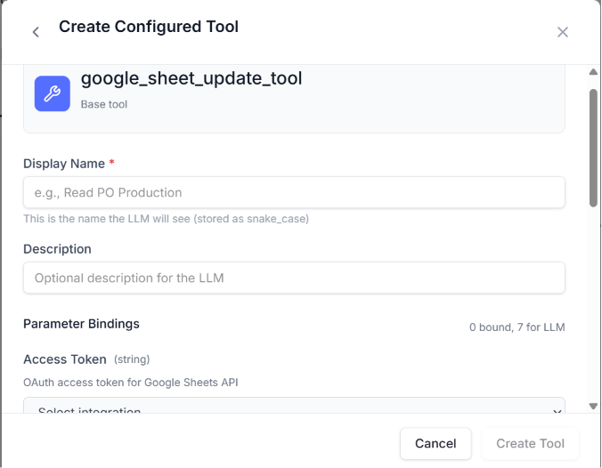📸

Screenshot: Create Configured Tool dialog — Access Token dropdown showing google_sheets account selection

Step 4D | Click 'Create Tool'  Once your Google account is selected, click 'Create Tool'. The tool will appear as a tag below the instruction box (e.g., 'Google Sheets Update ⚙ ×').

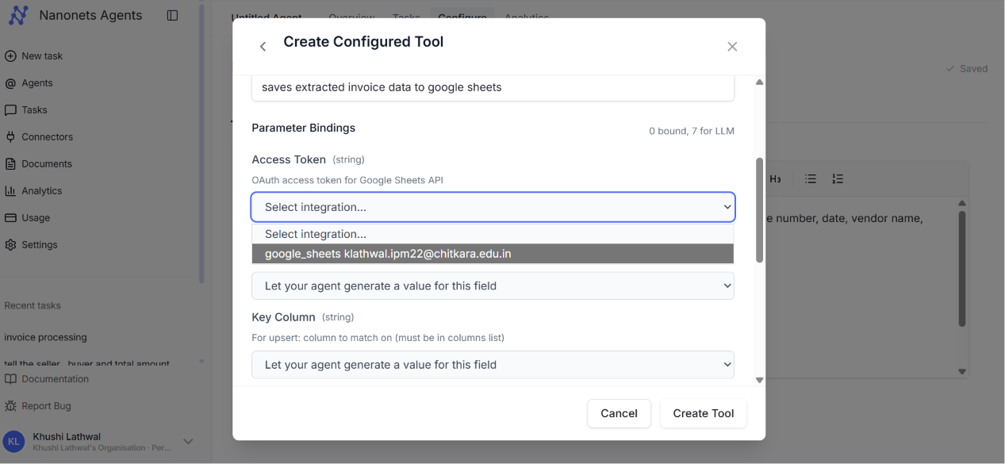📸 Screenshot: Agent Configure tab with 'Google Sheets Update' tool tag added at the bottom

💡 The agent is now configured. It knows what to do (extract fields from invoices) and where to save the output (your Google Sheets account).

Step 5: Set the Trigger — 'Run When'
You can set the agent to run automatically whenever it receives an email with invoice attachments. This is optional but very powerful for hands-free automation.

Step 5A | Click 'Run when...' in the agent panel  In the bottom-left of the Configure panel, click 'Run when...'. Then click '+ Add'.

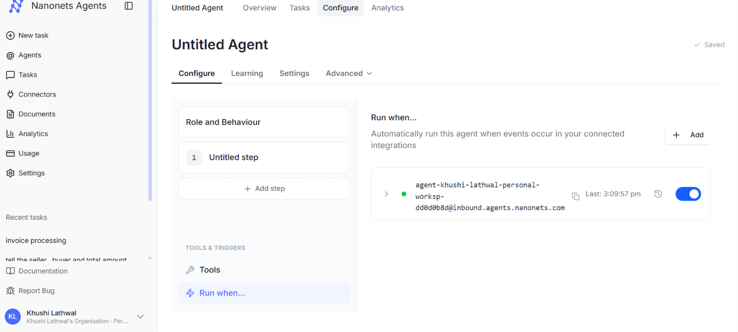📸 Screenshot: Agent Configure tab — 'Run when...' section with '+ Add' button

Step 5B | Note your agent's email address  Nanonets generates a unique inbound email address for your agent (e.g., agent-khushi-lathwal-personal-worksp-dd0d0b8d@inbound.agents.nanonets.com). Any email sent to this address will automatically trigger the agent.

💡 Copy this email address. You will use it in Step 6 to send invoices directly to the agent from your email client.

Step 6: Send Invoices to the Agent
Now you will trigger the agent by emailing invoice PDF files to its unique address.

Step 6A | Open your email client (Gmail, Outlook, etc.)  Compose a new email. In the To field, paste your agent's inbound email address from Step 5.

Step 6B | Attach invoice PDFs  Attach as many invoice PDFs as you want to process. In this example, 10 invoices (INV-2024-001 through INV-2024-010) were attached in one email.

Step 6C | Add a subject line and send  Add a descriptive subject like 'invoice processing' so you can identify this task later. Click Send.

💡 The subject line becomes the task title in the Nanonets dashboard. Use something descriptive so you can find it easily.
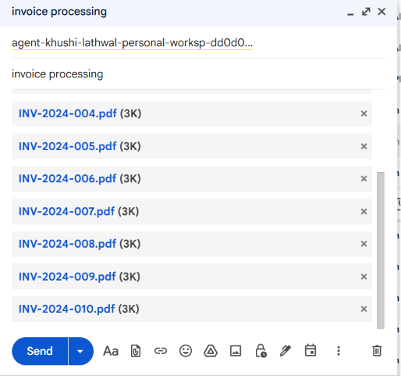

Step 7: Monitor the Task
After sending the email, go back to the Nanonets Agents dashboard to watch the agent work in real time.

Step 7A | Go to the Tasks page  Click 'Tasks' in the left sidebar. You will see your task listed with a status of 'Running' or 'Completed'.

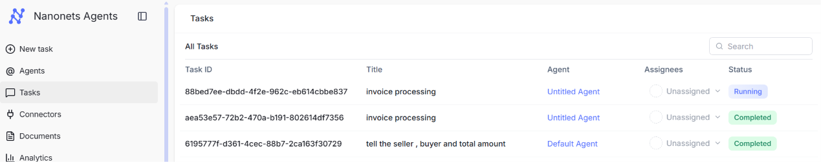📸 Screenshot: Tasks page showing invoice processing task with 'Running' and 'Completed' statuses

Step 7B | Open the task to see progress  Click on the running task to see the agent's live progress: Data Extraction, Analyzing Invoice Data, Populating spreadsheet rows, Finalizing, Concluding.

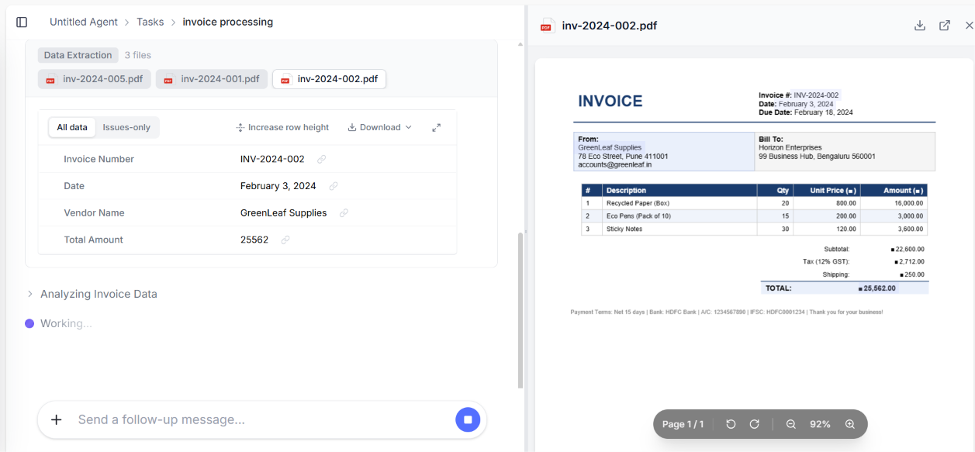📸 Screenshot: Task detail view — agent extracting invoice data from PDF files in real time (Working... indicator)

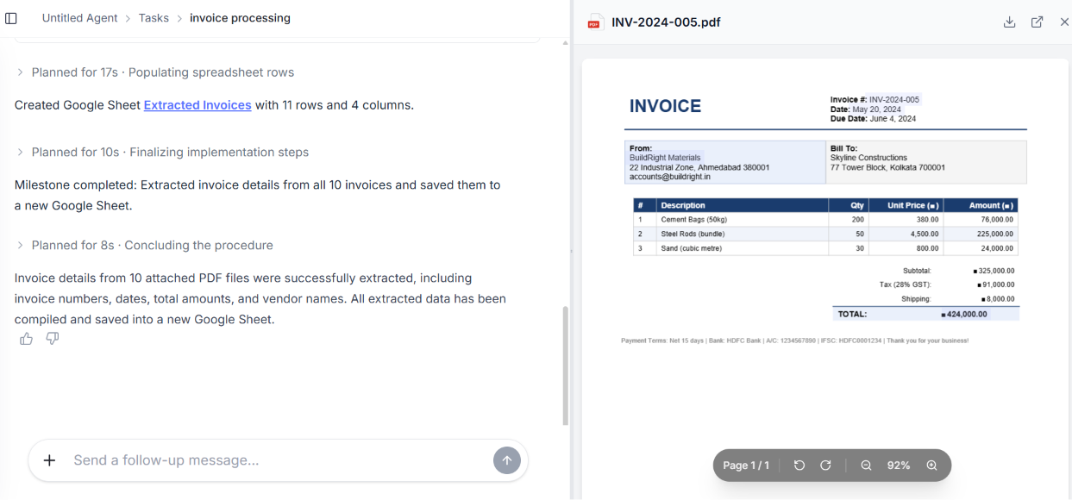📸 Screenshot: Task detail view — milestone completed: 'Extracted invoice details from all 10 invoices and saved to Google Sheet'

💡 The agent processes all files concurrently and shows a milestone summary when done. For 10 invoices, the entire process typically takes under 2 minutes.

Step 8: Verify Results in Google Sheets
Once the task status shows 'Completed', open the Google Sheet to verify the extracted data.

Step 8A | Find the link in the task output  In the task result, Nanonets will mention the name of the Google Sheet it created (e.g., 'Extracted Invoices'). Click the link, or open Google Drive and look for a new sheet with that name.

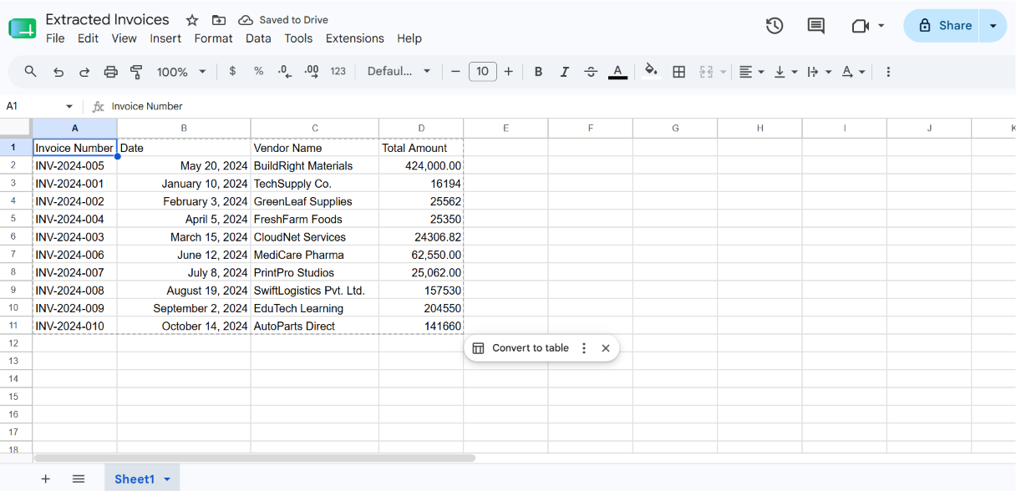📸 Screenshot: Google Sheets — 'Extracted Invoices' spreadsheet with 10 rows of data (Invoice Number, Date, Vendor Name, Total Amount)

Your spreadsheet will contain columns for:
- Invoice Number — e.g., INV-2024-001 to INV-2024-010
- Date — e.g., January 10, 2024
- Vendor Name — e.g., TechSupply Co., GreenLeaf Supplies
- Total Amount — e.g., 16194, 25562, 424000

💡 The agent correctly handles different invoice formats, tax structures (GST 12% vs 28%), currency symbols, and vendor layouts — without any manual template configuration.

Quick Reference Summary

Step | Action | Where to find it
1 | Sign up / Log in | nanonets.com → Get Started
2 | Connect Google Sheets | Sidebar → Connectors → Google Sheets → Connect
3 | Create agent + write instruction | Sidebar → Agents → New → Configure tab
4 | Add Google Sheets Update tool | Configure tab → + Add tool → Search 'google sheets'
5 | Set email trigger | Configure tab → Run when... → + Add
6 | Email invoices to agent | Gmail/Outlook → To: your agent's inbound email → attach PDFs
7 | Monitor task progress | Sidebar → Tasks → click your task
8 | Check Google Sheets output | Google Drive → Extracted Invoices spreadsheet

